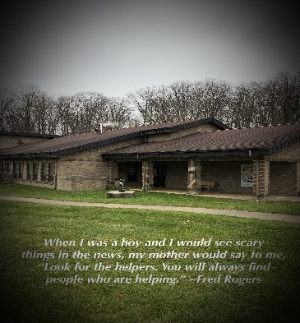
North Central State College
The Ohio State University Mansfield
Child Development Center
Early Head Start
Annual Report July 2019-June 2020

Our Mission
To provide quality care and education for children in partnership with families and the community.
Our Strategic plan is to promote healthy prenatal outcomes for expectant families, enhance the development of very young children and promote healthy family functioning.

What is Early Head Start
As a program designed by the United States Department of Health and Human Services, Early Head Start provides and promotes comprehensive services, to low-income families. Early Head Start aims to encourage greater social competence and school readiness in young children by:
- Fostering stable family relationships;
- Improving children’s physical, social, and emotional health;
- Organizing an environment to develop strong cognitive, language, literacy and mathematics skills, as well as exposing children to science and technology, social studies and the arts.

Enrollment and Families Served
Total Prenatal through Age Three Enrolled: 57
Total Families Served/Enrolled: 44
Total Number of Children who received Child Care Subsidy: 12
Total Number of Children Served on an Individual Family Service Plan or an Individual Education Plan: 15

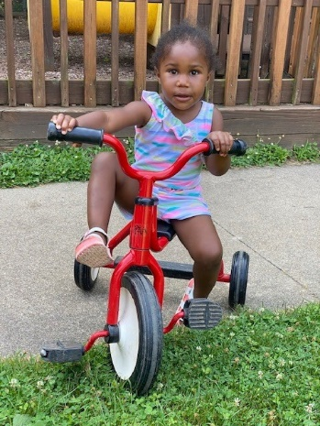

Medical and Dental Examinations
Total Number of Children with a Medical Home: 57
Total Number of Children who received Oral Health Screening: 57

School Readiness Outcomes
North Central State College/ The Ohio State University-Mansfield Child Development Center
Early Head Start Children Meeting/ Exceeding Widely Held Expectations
PY 2019-2020
June-July

For many families, early childhood programs looked different the end of FY19-20 than it has in previous years. Our program closed March 24, 2020 because of the Coronavirus-19 pandemic. During the weeks of closure, the program offered virtual learning and provided family resource bags. The program provided a responsible restart on June 8, 2020.

Budgetary Expenditures and Proposed Budget
FY2019-2020

Department | Program Operation | Training & Technical Assistance | Non-Federal Share
Child Health and Development Personnel | $217, 102 | $0 | $30,930
Family And Community Partnership Personnel | $23,743 | $0 | $0
Program Design And Management Personnel | $45,367 | $0 | $0
Employee Benefits | $174,576 | $0 | $25,476
Travel for Staff Development | $0 | $1,648 | $0
Supplies | $8750 | $0 | $0
Contractual/Administrative | $21,625 | $0 | $0
Depreciation/Use Allowance | $0 | $0 | $11,752
Utilities/Telephone | $0 | $0 | $11,045
Building and Child Liability | $0 | $0 | 3,603
Local Travel | $3,000 | $9,789 | $0
Volunteers | $0 | $0 | $8,857
Other-Shared Services | $0 | $0 | $3,000
Other-Custodial | $0 | $0 | $31,124
Other-Cell Phones | $0 | $0 | $450
Other-Duplicating | $0 | $0 | 1,000
Other-Other | $2,749 | $0 | $0
Dues | $600 | $0 | $0

Direct Costs | Cost for Program Operation | Cost for Training Technical Assistance | Non-Federal Share | Number of Employees
Direct Cost Total | $497,512 | $11,437 | $127,237 | 18

Total: $636,186
Audit:12/2/2020

Public and Private Funding
The Child and Adult Care Food Program (CACFP) is a federally-funded United States Department of Agriculture Program administered by the Ohio Department of Education, Office of Integrated Student Supports. CACFP enables child care institutions to provide nutritious meals and snacks as a regular part of their child care and that contribute to the wellness, healthy growth, and development of infants and young children. The Child Development Center received $36,985.28 in FY 2019-2020 for meal reimbursement through the CACFP grant. Nineteen percent of the total meals served at the CDC was provided to Early Head Start Children.
~This institution is an equal opportunity provider~

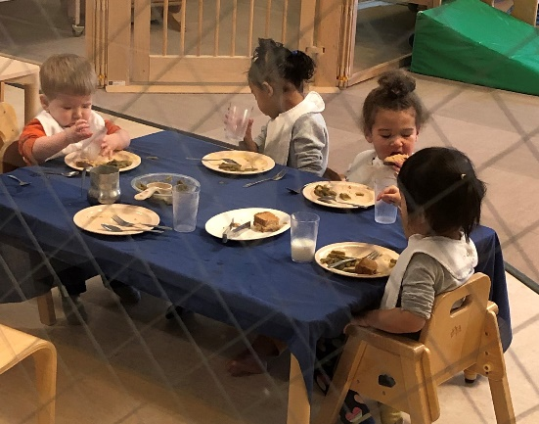

Family Engagement
Early Head Start Home Based Family Gatherings
Family meetings for socialization, snacks, and education
Policy Council and Parent Committee Once Monthly
Guest Readers
Picture Day
Dental Screening
Family Resource Spotlight
Language and Literacy Night
Family Surveys Parent/Teacher Conferences
Staff preparing Family Connection bags during Covid-19 pandemic
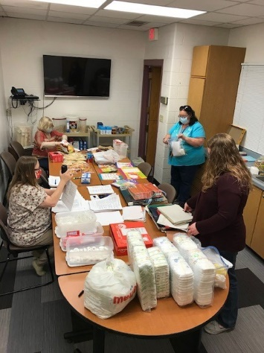

The Child Development Center is licensed by the Ohio Department of Job and Family Services in accordance with requirements of the Ohio Revised Code.
You may visit http://www.jfs.ohio.gov/CDC/childcare.stm to view compliance inspection reports.
The state of Ohio has awarded the Child Development Center a 5-Star Rating for meeting the quality standards established by the Ohio Department of Job and Family Services and the Ohio Department of Education. Step Up To Quality is a Five-Star Tiered Quality Rating and Improvement System created to recognize and promote early learning and development programs that meet quality standards over and above the health and safety licensing requirements.

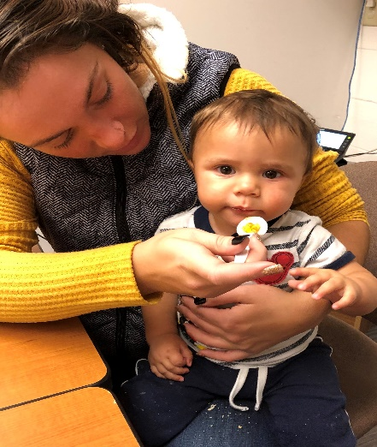
Family Night November 2019
Community Partnerships

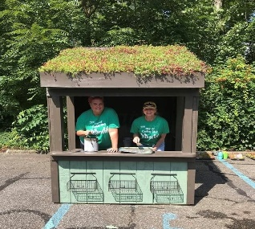

Richland County Job & Family Services
Richland County Children Services
Third Street Family Health Services
Richland Pregnancy Services
Richland County Public Health
Ohio Heartland Head Start
Richland County Local School Districts
Catalyst Life Services
Mansfield Richland County Public Library
Gorman Nature Center
Little Buckeye Children’s Museum
Help Me Grow, Early Intervention
WIC Services
YWCA Child Care Resource & Referral Agency
Richland County Youth and Family Council
Ohio Child Care Resource & Referral Agency
Nationwide Children’s Hospital
The Domestic Violence Center
Harmony House Homeless Shelter
Parent Aid
Richland County Juvenile Court GAL/CASA
North Central State College
The Ohio State University Mansfield

Interested in knowing more about the Child Development Center and how to enroll? Call or visit
2441 Kenwood Circle, Mansfield, OH 44906
Phone: 419-755-5600 * Fax: 419-755-5605
cdc@ncstatecollege.edu
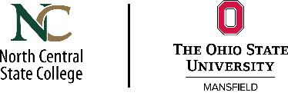
You can find a copy of the annual report for fiscal year 2019-2020 on our webpage https://ncstatecollege.edu/child-development-center/

