Assessment Committee Meeting Minutes
Friday, November 6, 2020

- Opening: The regular meeting of the Assessment Committee was called to order at approximately 12:00 on Friday, November 5th by Justin Tickhill. This meeting was held online via ZOOM.
- Present: Chris Barker, Justin Tickhill, Dan Wagner, Dr. Gina Kamwithi, Dr. Karen Reed, Deb Hysell

- Minutes
Minutes from October 2nd were reviewed and approved.

- Discussion about December 4th meeting
This meeting would be a coming together of the entire group. However, there was some discussion to postpone to the next semester because it is finals week. The Assessment Course team majority expressed support for meeting December 4th. This will be discussed at the PF/SS meeting and voted upon.

Minutes from the PF/SS Meeting Reviewed
To help with communication Justin reviewed the minutes from the PF/SS group. Some time was spent talking about the addition of ‘Growth Mindset” as a soft skill.
Some discussion also surrounded professional presence in zoom.

Assessment Course Structure and Material
As an example of the ‘working meeting’ structure of this team, the team worked on the upload for the TASK assignment. It was renamed, instructions changed, and placed higher in the module so faculty can see this easily when they come to upload the Tuesday before Thanksgiving.

CWO
Discussion revolved around how we have deployed the CWO’s. We also discussed how to get the matrix updated.
CWO’s may be on syllabi where they should not be displayed. Much was discussed about the concepts of CWO and mastery. At this time, faculty deploy CWO’s at the introduce, reinforce and mastery level. However, the team believed it was only mastery.
We started our program in 2013 requesting the I, R, M framework. However, for simplicity we moved to merely an X in the

PARS
Discussion around Justin’s updating of language within CANVAS, related to the purpose of PARS. Questions were raised if what he stated would only apply to the Technical Programs. See point of discussion below.
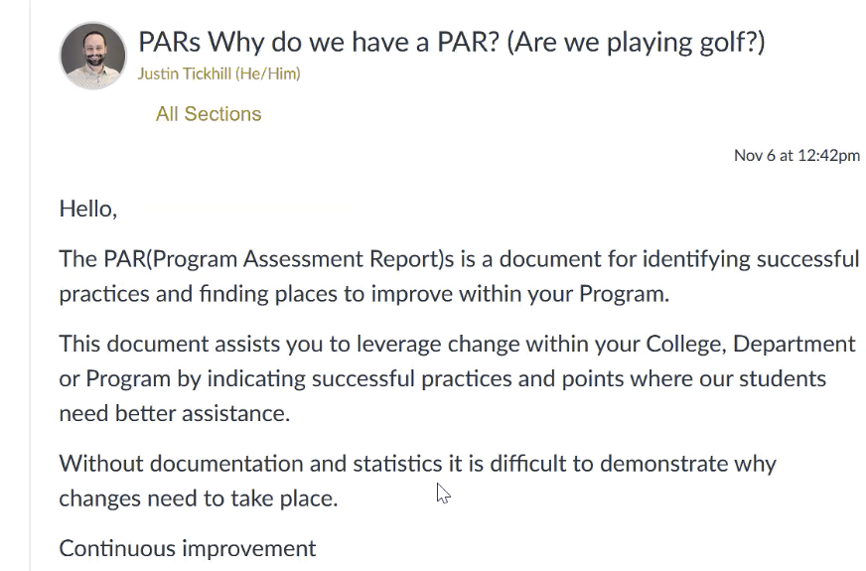

Review of a topic in previous minutes
Show and Tell PARS. Between PDF and video, it was decided both would work if you could make the videos a maximum length of 5 minutes.

Co-Curricular Integration
The question of where to add the Co-curricular folks was discussed. The entire structure will be discussed the beginning of Spring semester.

Back to Reviewing PARS
It was brought up that we need to support our new people with reviews of their PARS. So, that must be added to our duties for Spring semester.
Additionally BAS will need annual reviews for ABET.
The idea was brought up that we should allow observers of the new faculty when we do PARS reviews.

- Adjournment
1:28p.m.
The next meeting will be November 20th which will be focused on the soft skills.

Submitted by Gina K.

